
Please return the completed form to the reception of Mövenpick Resort & Spa Fruške Terme hotel.

The reservation is valid only in this format.

Date:

Full Name:

City:

Country:

E - mail:

Arrival Date:

Departure Date:

Hotel Movenpick Resort & Spa Fruške Terme 4* 22.09-24.09.2027.

Bed & Breakfast:
– EUR 140.00 per night in a single room
– EUR 77.00 per person per night in a double room

Tourist tax: RSD 110.00 per person per night
Price in RSD depends on the National Bank of Serbia middle exchange rate on the invoice date

Package includes:
- Check-in at 14:00, check-out at 11:00
- Accommodation based on selected service
- Water world (spa pools)
- Sauna world
- Non-alcoholic minibar + coffee machine in the room
- Garage parking

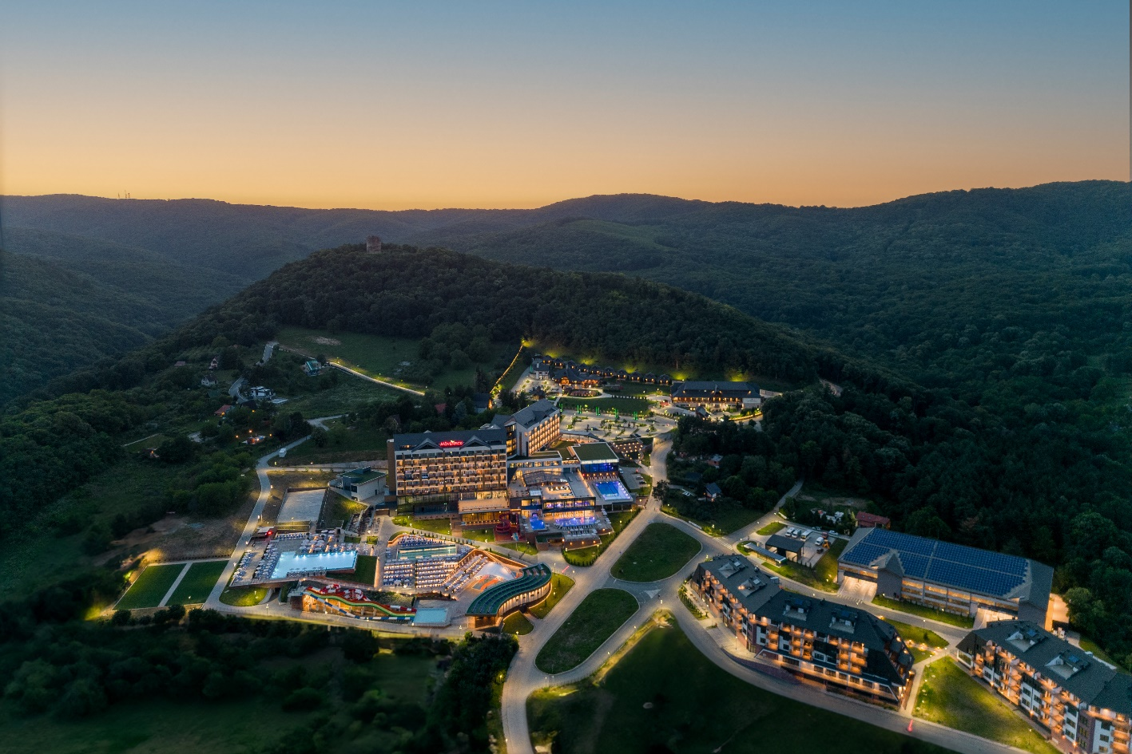

Accommodation type (subject to availability):
Please mark the desired option:
1. Single room (for one person)
2. Double room (for two persons)

A 100% advance payment is required to confirm the reservation.
If payment is to be made via a company account, company ID details must be provided.

Accommodation reservations can be made no later than 10.09.2027, subject to availability.
For reservations after this date, the hotel does not guarantee price or availability.

Cancellation policy: 14 days before arrival: 50% of the paid amount is retained, 7 days before arrival: 100% of the paid amount is retained.
We wish you a pleasant stay!

Reservation contact: info@frusketerme.com

Phone: 022/21-55-260
063/495-477

